OPERATING SYSTEM ASSIGNMENT - 2

Name: Deepika Rani
Roll No: 2401201131
Course: BCA (AI & DS)
Subject: Operating System
Assignment 1: Bankers Algorithm

1.INTRODUCTION
Banker’s Algorithm is a deadlock avoidance algorithm used in operating systems.
It helps in determining whether a system is in a safe state or not by analyzing resource allocation.
In this assignment, we implemented Banker’s Algorithm using Python to check system safety.

2.OBJECTIVE
The objective of this assignment is to understand and implement Banker’s Algorithm and determine whether the system is in a safe or unsafe state.

3.TASK 1: INPUT & DATA REPRESENTATION
In this task, we took input for Allocation Matrix, Maximum Matrix, and Available Resources from the user. These values are used to analyze the system state.
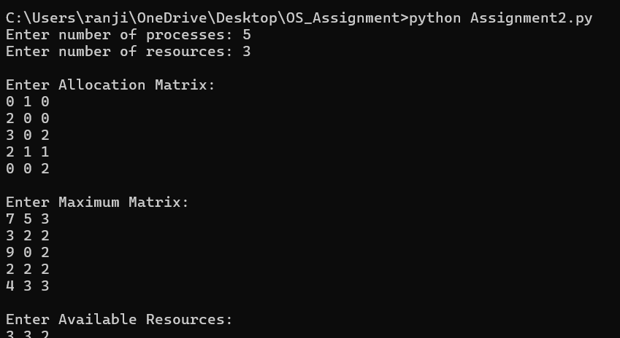52

4.TASK 2: NEED MATRIX
Need Matrix is calculated using the formula:
Need = Maximum - Allocation
It represents the remaining resources required by each process to complete execution.
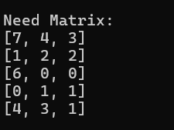

5.TASK 3: SAFETY ALGORITHM
The Safety Algorithm is used to determine whether the system is in a safe state.
It checks if all processes can complete execution without leading to deadlock.

6.TASK 4: SAFE SEQUENCE
Safe Sequence is the order in which processes can execute safely without causing deadlock.
If a safe sequence exists, the system is considered safe.
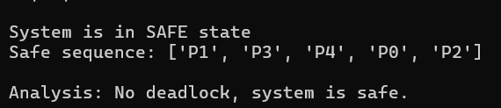

7.TASK 5: RESULT ANALYSIS
If all processes are able to execute successfully, the system is in a safe state.
Otherwise, the system is unsafe and deadlock may occur.

